TeachEHR
Electronic Health Record System
User Manual
Modified: April 12, 2010

Table of Contents
Users 3
Creating a New User 3
Selecting a User to Edit 3
Editing a User 4
Editing Your Self 4
Patients 5
Creating a New Patient 5
Creating a Patient from Scratch 5
Creating a Patient from Master 6
Selecting a Patient 6
Selecting Collaborators 6
Selecting and Creating Classes 7
Main Patient Page 8
History/Physical 8
Nurses Notes/Physician’s Orders 9
Daily Assessment 9
Daily Assessment Setup 9
Patient Information 10
Lab Reports 10
Activities/Daily Living 10
Medicine Control 11
Administer Medicine 11
Add/Edit Medicine Administration Schedule Items 12
Administer Medicine Options 12
User History 12

Users

Creating a New User
New Users are created by having the new user go to the system and attempt to login.
They will be prompted with a box to enter their information.
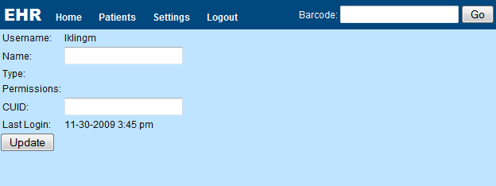
Once they enter their name and CUID barcode (printed below the barcode) and click submit. They will have an active user account in the system.

If this user is a teacher or admin, the current admin can then go in a promote them. By default the user will simply be a student.

Selecting a User to Edit
If you have the permissions to edit users, an option at the top of the page will be Edit Users.
Click this will reveal a list of all the users in the system sorted by their username.
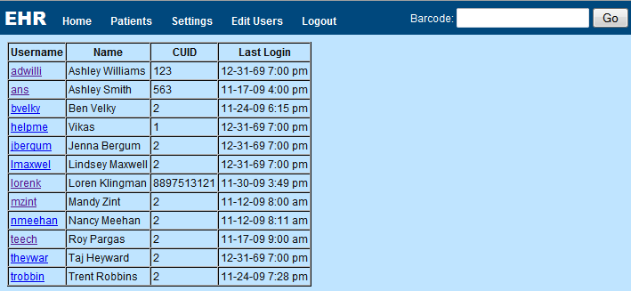
To edit a user click on the user’s username.

Editing a User
Once you have selected the user, you may edit their information.
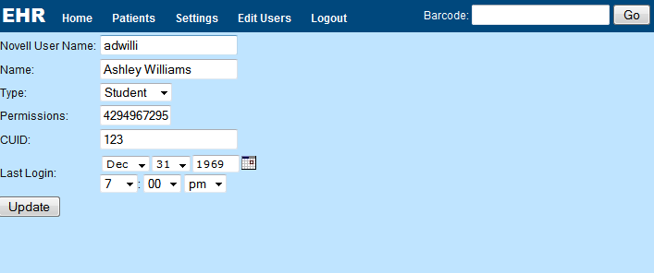
Changing the novell user name of a user is not recommended since this is unlikely to have changed.
Name is simply the user’s name.
Type is the type of user that they are, currently this does not affect anything in the system though it may be used to suggest a permission number.
Permissions is a number generated to allow and disallow certain actions. It is created by adding together the numbers of all the actions the user may perform. This guide will be updated to contain all the numbers in the future and recommended numbers for different types of users.
CUID should be the number from the barcode on the back of the user’s CUID. This will later be used to verify medicine administrations.
Last Login is the time the user last logged on and should not need to be edited.

Editing Your Self
All users can edit their own information by clicking Settings at the top of the page.
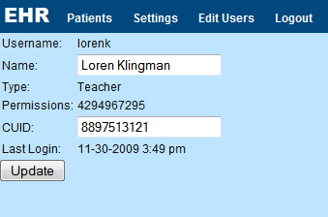
Users can only edit their name and CUID barcode.

Patients

Creating a New Patient
New patients can either be created from scratch where the administrator or teacher enters all of the patients information or from a master where the user copies a master patient and then updates specific data.

Creating a Patient from Scratch
On the patient listing page, click New Patient from Scratch.
This will bring up a screen to enter the patient information.
Barcode will be generated by the system later so we can skip that.
First/Middle/Last Name is the name for the patient.
Address/City/State/Zip is the patient’s address.
Phone is the patient’s phone number.
Birthday is the patient’s birthday.
Social Security # is the patient’s social security number.
Insurance Name/Number is the patient’s insurance information.
Race is a select for the race of the patient.
Gender is a select for their gender.
Primary Physician is a box to enter the primary physician’s name.
Select Primary lets you select a user of the system as the primary physician for this patient. (Currently this doesn’t do anything for that person. In the future it may give them special access or cause them to receive reports from the nurses.)
Viewable by allows the selection of who can view the patient. (Hold Ctrl to select multiple names.) Clicking select a class will open a pop up where you can click on a class to select all the members of that class and where you can enter a new class.
Show to all allows for selection of people where all students can see the information.
Skip Collaborators for now.
Daily Assessment Info is the selection of information for the daily assessment to contain. Clicking on templates will open a popup with templates to choose from. See Daily Assessment Setup for information about creating your own assessment.

Creating a Patient from Master
On the patient listing page, click New Patient from Master.
This will bring up a list of all the master patients organized by the person who created them.
Any master’s that you created will be listed first.
If you click on the name of a master, a copy of that master will be created with your name appended to the end.
You will be taken back to the patient listing page where you can click on the name of the new copy and edit the information/change the name.

Selecting a Patient
From the patients listing page (accessed by clicking Patients at the top of any page), click on the name of the patient to select it and be taken to that patients main page.

Selecting Collaborators
Members of a collaboration group share all their entries into the system. Users who are not members of a collaboration group will only see their own entries. All users will also see any entries made by the patient creator and users listed under show all.
To get to the collaborator selection page: Select a patient, click the patient information button on the left side. Now click the collaborators link.
You will be brought to a page listing all the users who can view the patient on the left and the collaboration groups on the right. Names will be gray if that user is currently a member of one or more collaboration groups.
If the patient has no collaboration groups currently, the right will be blank.
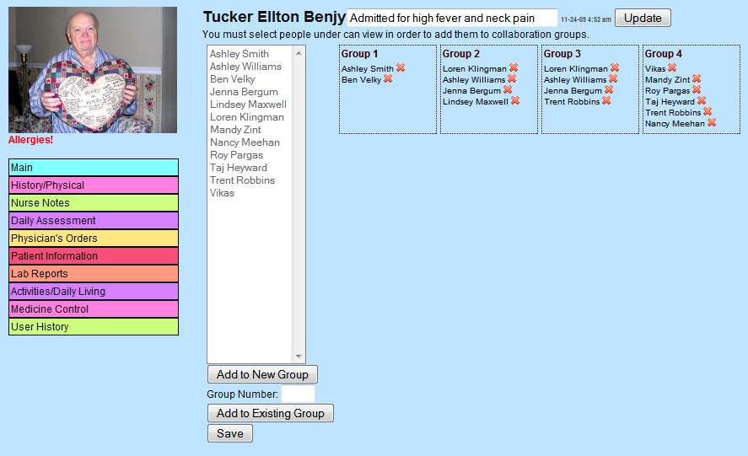
Clicking the X next to a users name removes them from the group. If all users are removed from a group, that group will disappear.
You may select users on the left by clicking on them, multiple users can be selected by holding Ctrl while clicking on the names.
Once you have selected users you may add them to a new group by clicking Add to New Group or add them to an existing group by entering the group number in the box and then clicking Add to Existing Group.
Once you are happy with the collaboration groups, click Save at the bottom to save all the entries.

Selecting and Creating Classes
To get to this page: Select a patient, click the patient information button on the left side. Now click the select class link.
A popup will appear listing all the classes currently setup in the system.
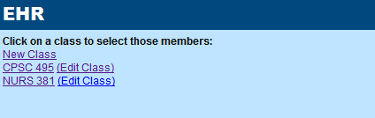
Clicking on the name of the class will result in all the members of that class being selected in the can view box in addition to any users already selected.
Clicking New Class will allow you to create a new class.
Clicking Edit Class brings up a nearly identical page, but with the current information for that class already filled in.
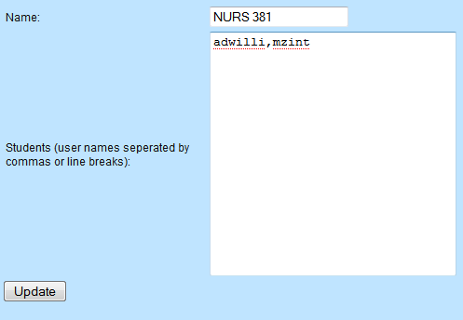
Here you fill in the name of the class and the usernames of the students in the class. The usernames may either by separated by commas (as pictured) or by pressing the enter key.

Main Patient Page
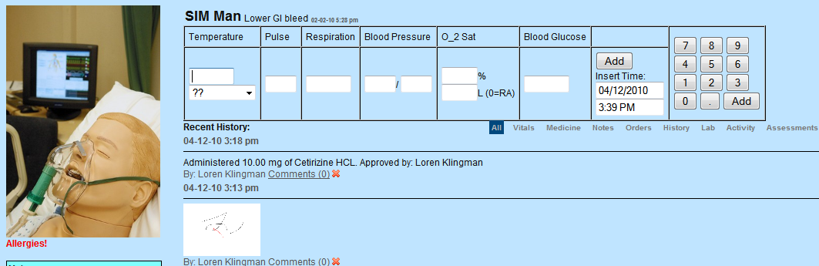
The main patient page, displays the patients photo.
Clicking on the photo will show a box to upload a new photo.
You can also edit the status box at the top and click update to change the patient’s status by changing it and clicking update.
The main use of this page is to add vitals information.
This is done by filling out the boxes and clicking on Add.
Only numbers should be entered and the cursor will auto-advance between the boxes.
Temperature should have 1 number after the decimal.
Pulse, Respiration, and Blood Pressure should just be a number.
O₂ Sat percentage has 1 number after the decimal and liters has none.
Blood glucose is also just a number.
If you have the ability to delete, an X will appear next to each vital sign. Click on the X will allow you to delete that vital sign entry. This is useful for entering base data in case of an incorrect entry.
Clicking on comments will allow you to view comments and add a new comment.

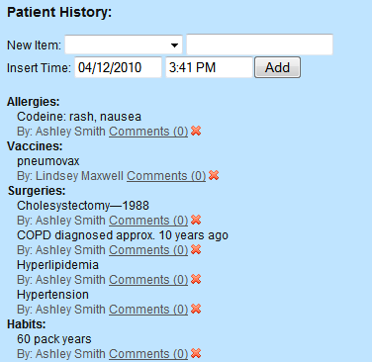
History/Physical
This page is accessed by clicking on History/Physical on the left of a patient page.
This page displays information about the patient.
As with all the pages, you can only remove items if you have the appropriate permissions.
To add a new history item, simply select the item category from the drop down and enter the item in the box and click add.
The item will then appear in the listing with that category.
If you are adding an allergy item, it will not appear in the list when you mouse over allergies under the patient’s picture until you visit a different page.

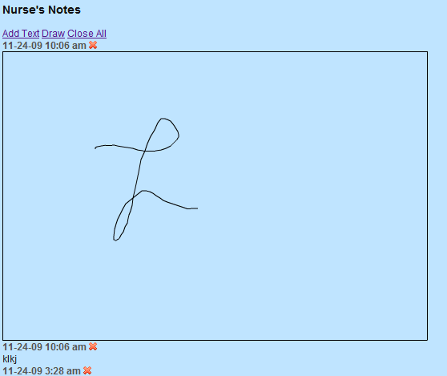
Nurses Notes/Physician’s Orders
These pages can be accessed by clicking on the link on the left of a patient page.
The two pages are identical except for the information that is displayed.
The displayed notes can either be ink images or text.
As with the other pages, the red x to delete is only displayed if the user has that permission.
Clicking Add Text at the top will open a text box to add text notes to the patient.
Clicking Draw will open a box to draw using the mouse or a touch screen.
Clicking Close All will just close the box at the top of the screen if you opened it accidentally.
Clicking on an image will enlarge it to full size for viewing. You can also draw to comment on these images.

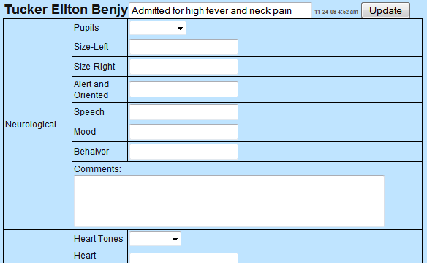
Daily Assessment
This page can be accessed by clicking daily assessment on the left of the page.
The first page you arrive to displays a list of the previously completed daily assessments and the times. You can click on the time to view all the information that was entered.
There is also a link to Enter Assessment which allows a new daily assessment to be entered.
When entering a new assessment you receive a page of text boxes and drop downs based on what was entered in the daily assessment box on the patient information page.
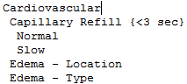
Fields are not required so you can leave them blank. Doing so will result in Blank being displayed for the item on the display page for the assessment.

Daily Assessment Setup
Daily Assessments are entered by using line breaks and spaces.
A main item is on a line with no spaces before it.
Sub items are entered with one space before them on the lines after the main item.
If you have selection items for a drop down, those should be entered after the sub item with two spaces before the text.
Tips are entered between curly brackets (ex. {<3 sec}) this will place a ? after the item and the tip will appear when you mouse over the item.
See the example

Patient Information
This page is used to edit the information about a patient.
For details on this page see, New Patient From Scratch.
If you wish to edit patient information and the collaborators, edit the patient information first then click Update. Then click the link to edit collaborators.

Lab Reports
The main page displays a list of all the uploaded lab reports.
Clicking on the lab report name opens a PDF of the report.
Clicking Annotate Images will allow you to annotate the pages of the report. (If convert images is displayed instead, click that link and it will change into annotate images.)
To upload a new lab report simply click browse and upload a pdf file with a new report. If you have a file that is not a pdf, download a pdf printer and print the file to pdf.

On the annotate images page, you will be show a flash window to use the mouse to draw on the image, you may change the ink color and switch to an eraser at the bottom. Once you finish, click Save and the ink will be saved and displayed below the annotation window.
You can also change what page of the report you are viewing at the top.
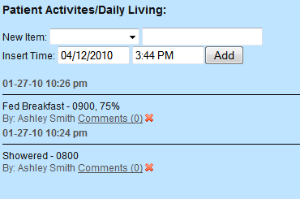
Any previous annotations will be displayed below the annotation area.

Activities/Daily Living
This page is accessed by clicking on Activities/Daily Living on the left of a patient page.
This page displays information about what the patient has done.
As with all the pages, you can only remove items if you have the appropriate permissions.
To add a new activity item, simply select the item category from the drop down, enter information if needed in the box, and click add.
The new activity will then appear in the list with the time it was entered, what was done, and then the note if one was entered.

Medicine Control
This page is accessed by clicking Medicine Control on the left side of the page.
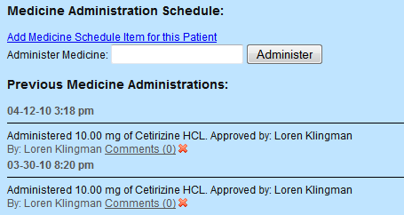
Medicine control allows student users to administer medicines by scanning the medicine barcode into the administer medicine box.
It also allows teachers to add a medicine item for the patient that should be administered and allows administrators to control the medicine options in the database.

Administer Medicine
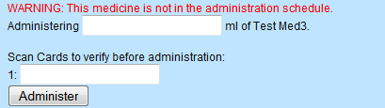
To administer medicine to a patient first the barcode is scanned into the box on the Medicine Control Page.
Then, the user enters the amount of the medicine to be administered.
If the medicine is not in the list of medicines that should be administered a red warning appears at the top of the page.
Finally, the user scans their card to verify that they are administering the medicine. Some medicines may require that multiple user’s cards are scanned before the medicine can be given.

Add/Edit Medicine Administration Schedule Items
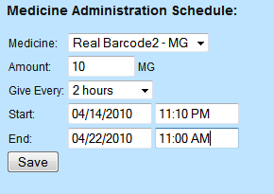
From the medicine control page, click on Add Medicine Item for this Patient to add a new item or click on the name of the medicine for an existing item to edit it.
Once at the page, select the medicine from the list of existing medicines.
Then, enter the amount. Only enter a number the units are displayed after the medicine name. (Eg. Name – ml. The units are ml so if you wanted to administer 5 ml, you would enter 5 for amount.)
Start date is when the medicine should start being administered.
End date is when the medicine should stop being administered.
Give every is how often the medicine should be given during these time frames.

Administer Medicine Options
This page controls the available medicines to be administered and can be accessed by clicking Administer Medicine Options at the top of the Medicine Control page.
Once on the page, a list of the current medicines is displayed, click the name of a medicine to edit it or click New Medicine to add a new medicine.
Changes made to the medicine options affect the medicines for all patients so generally adding a new medicine is better than editing an old on unless you are fixing a misspelled name.
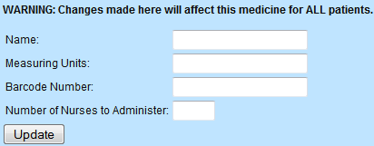
For name enter the name of the medicine.
Measuring Units are the units to administer the medicine (eg. ml, mg, etc)
Barcode number is the barcode for the item.
Number of Nurses to Administer is how many people are needed to verify the medicine administration. (This should generally be 1 or 2.)

User History
This page allows users to view what other users have done and the order in which they did it.
First, you select the user who’s history you would like to view.
Next, you select what session. A new session is made each time a user logs in.
Finally, you will be taken to a list of the user’s history.
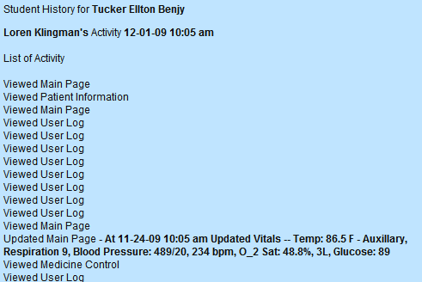
If the student interacted with multiple patients in that session, the list only includes how the student interacted with the patient you are currently viewing.
A viewed entry is made each time a page is loaded so multiple viewed entries can occur in a row for a page.
This also displays information about any new entries made or entries updated.

